Supplementary material
The figures below give the model inputs, sensitivity analyses, supporting result matrices, scale calculations and data maps on which the main text draws.
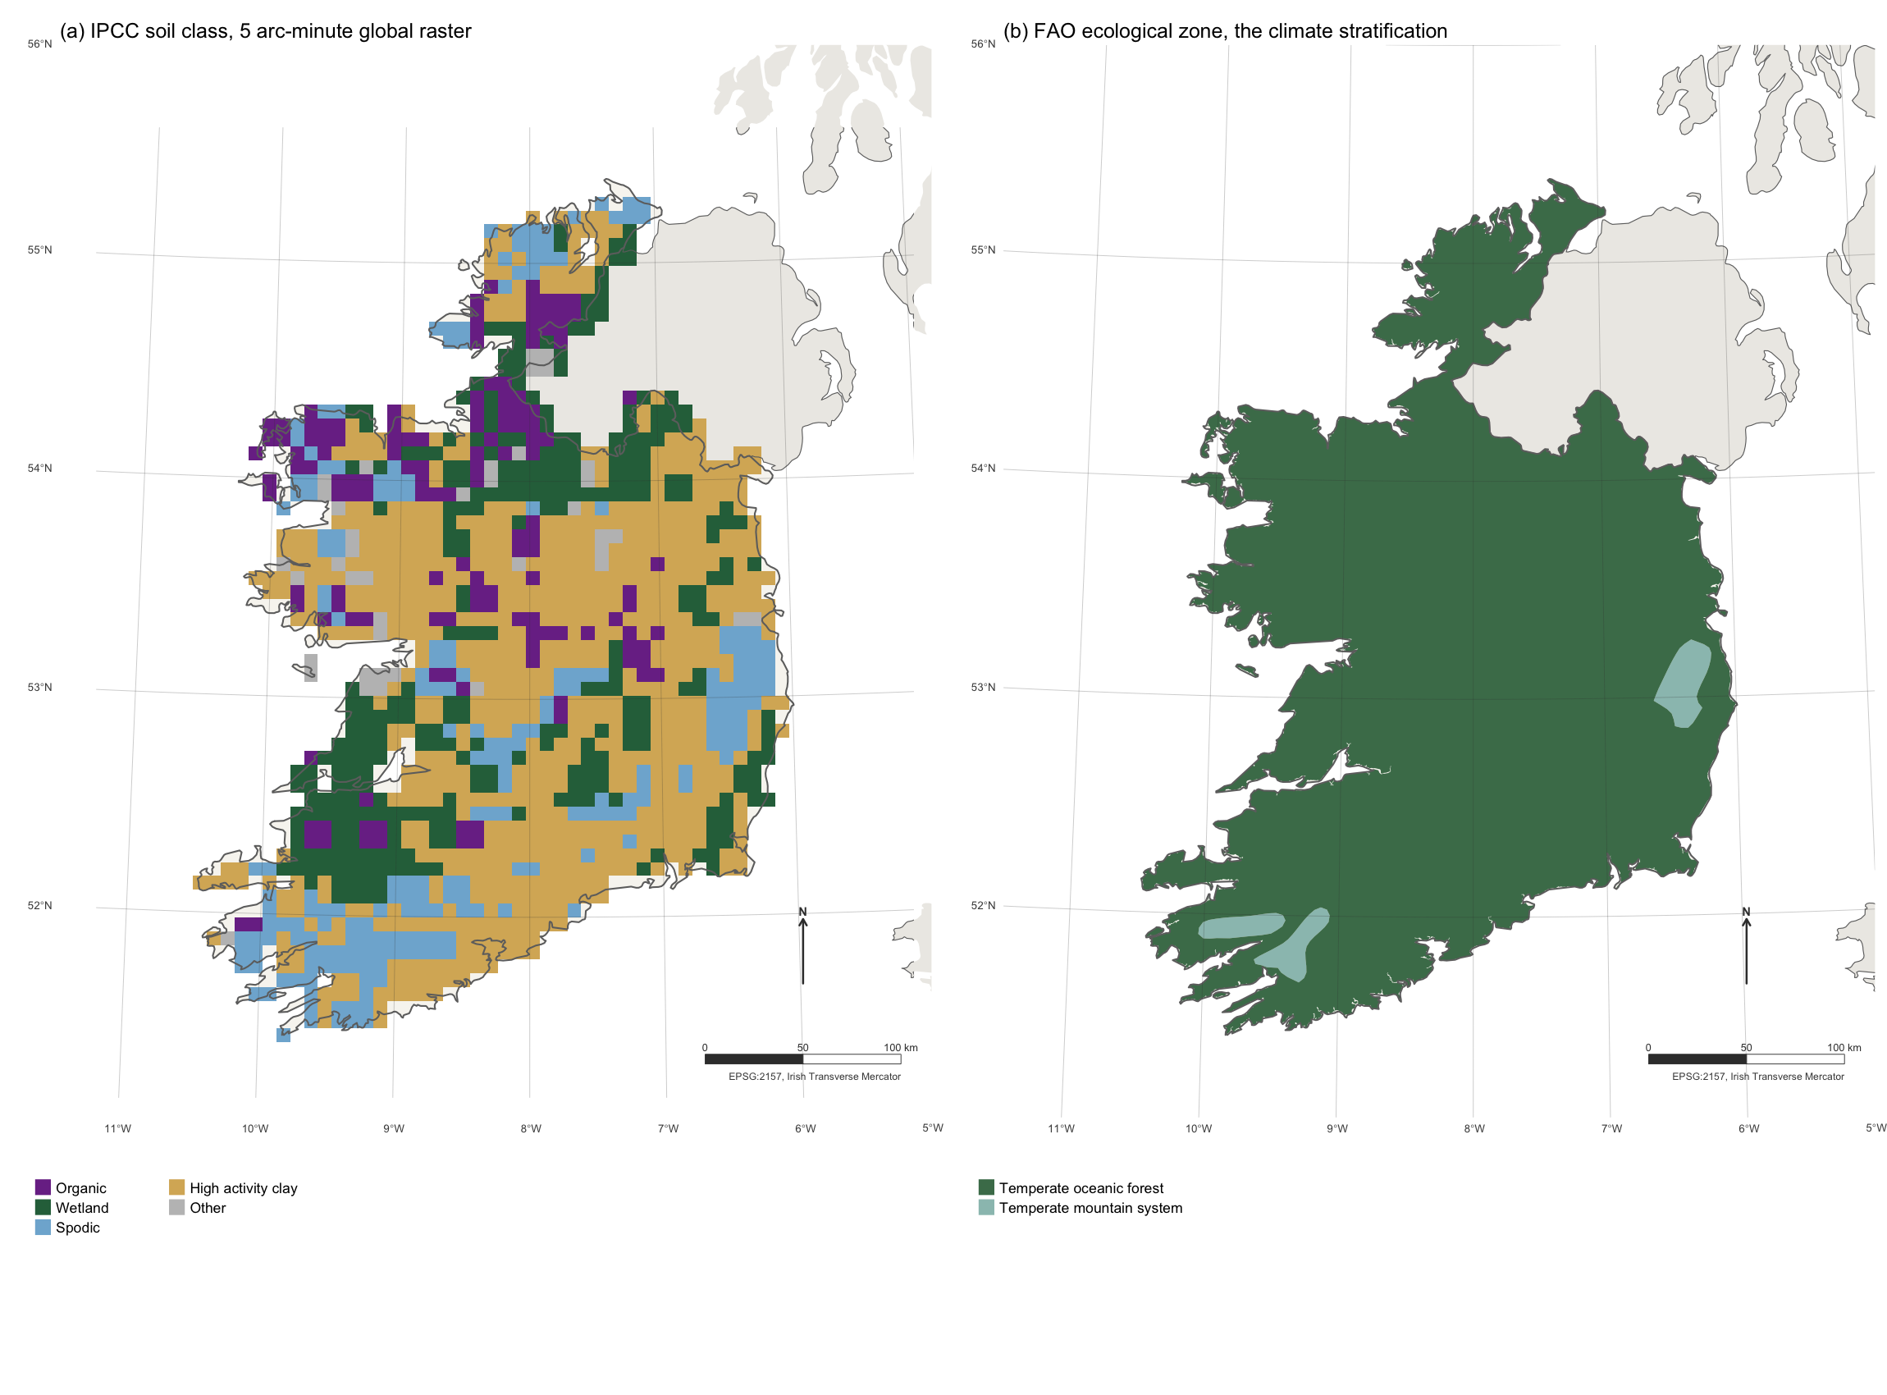
Figure S1. The two global layers that select which Tier 1 default applies, clipped to the Republic of Ireland. (a) The 5 arc-minute IPCC soil classification derived from the Harmonised World Soil Database. (b) FAO Global Ecological Zones 2010, the climate stratification. Graticule at one degree, EPSG:2157 Irish Transverse Mercator, north arrow and bar scale in the lower right of each panel.

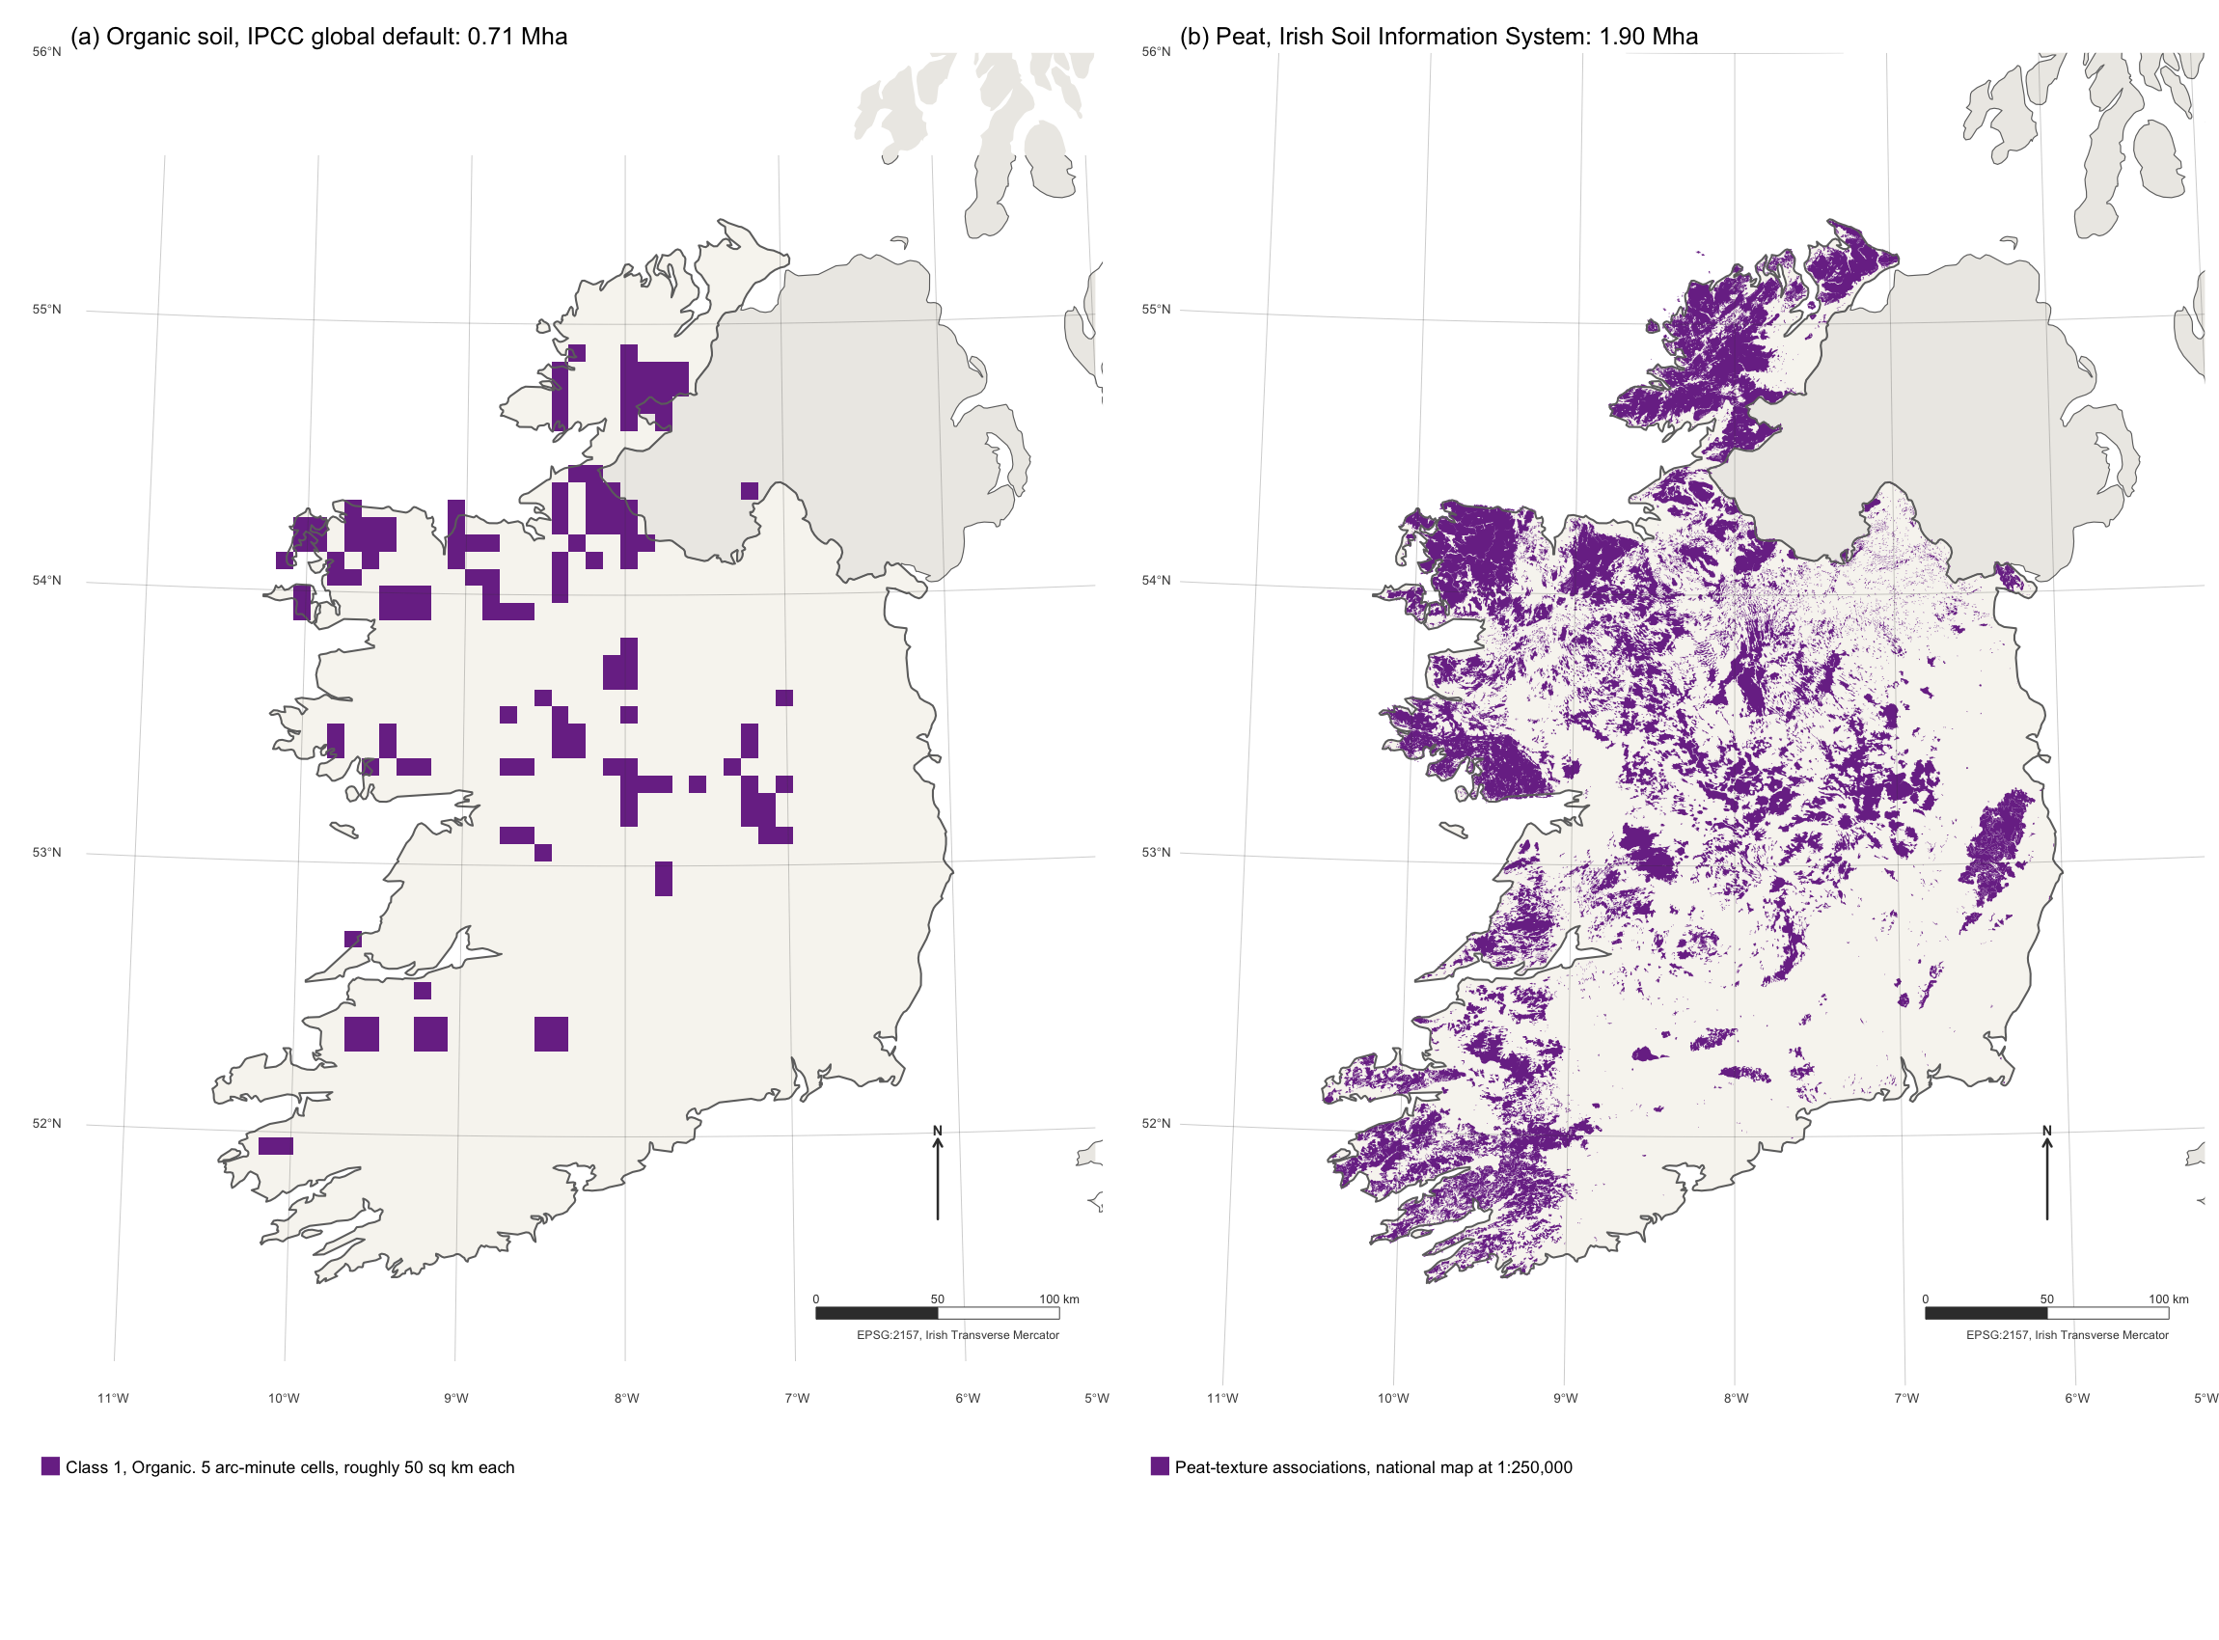
Figure S2. Organic soil as the global default has it, against the national map, at one scale. (a) Cells classified organic in the 5 arc-minute IPCC soil classification, the same layer underlying the estate map and the area weights. (b) Peat-texture associations in the Irish Soil Information System, 1:250,000. Areas are computed from the geometry in EPSG:2157. Graticule at one degree, north arrow and bar scale in the lower right.
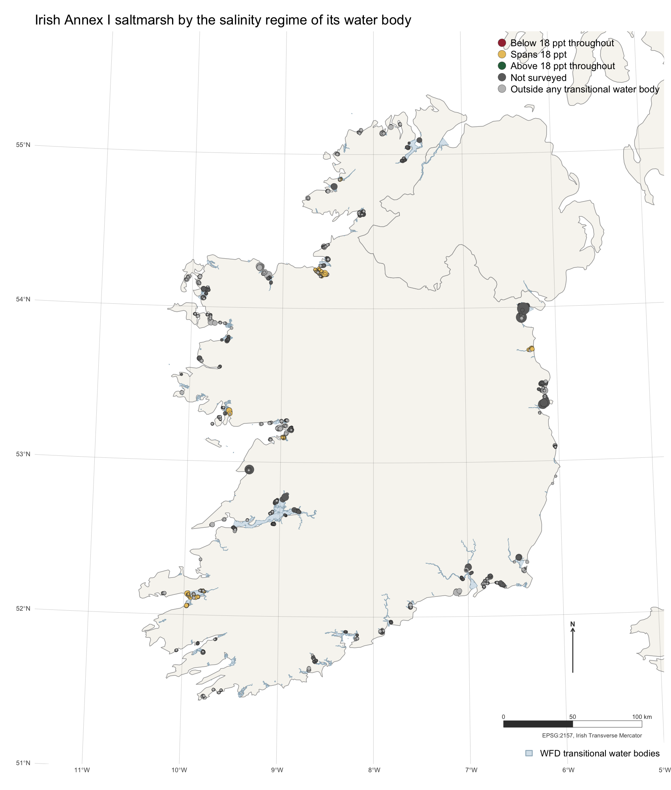
Figure S3. Confirmed Annex I saltmarsh in Ireland, sized by area and coloured by the salinity regime of the transitional water body containing it, over the Water Framework Directive transitional network. No polygon is classified above 18 ppt throughout, and nine tenths cannot be classified at all: dark grey sits in water bodies never surveyed, light grey outside the transitional network entirely.
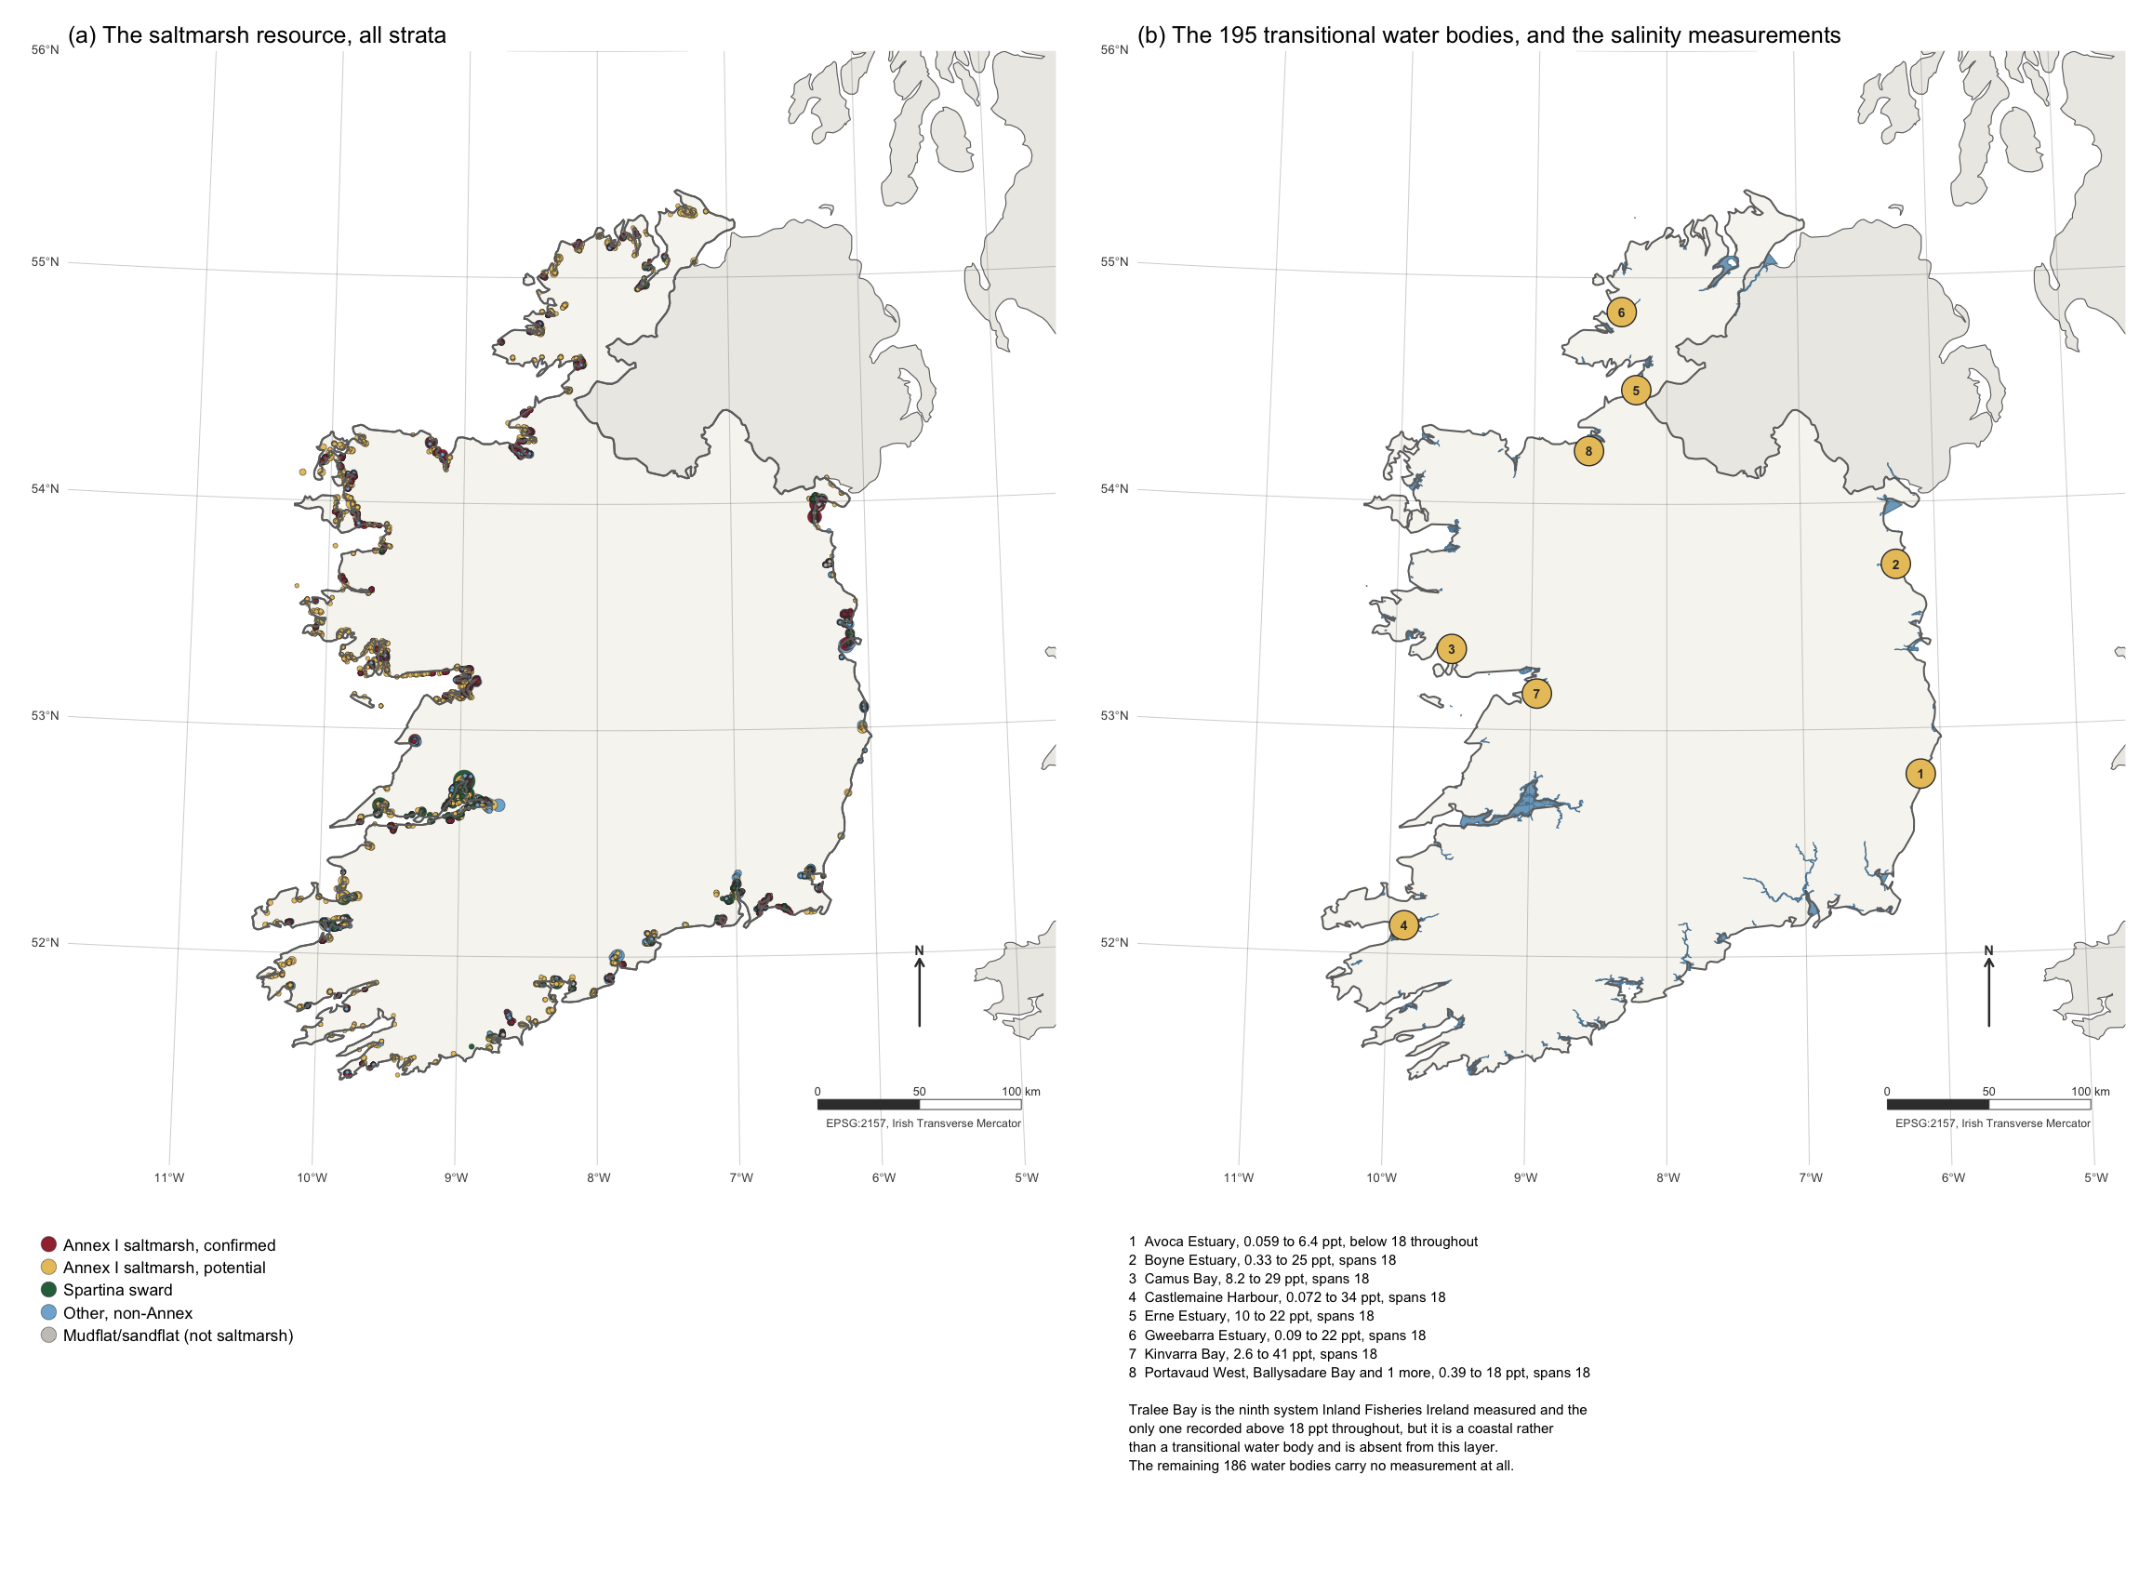
Figure S4. The two Irish coastal datasets behind the salinity gate. (a) The Saltmarsh Monitoring Project resource, all five strata, drawn at polygon centroids and sized by area. (b) The Water Framework Directive transitional water bodies, with the eight Inland Fisheries Ireland systems that carry a 2015 salinity numbered and keyed beneath. Tralee Bay, the ninth and the only one above 18 ppt throughout, is a coastal water body and is not in this layer. Graticule at one degree, EPSG:2157, north arrow and bar scale in the lower right.
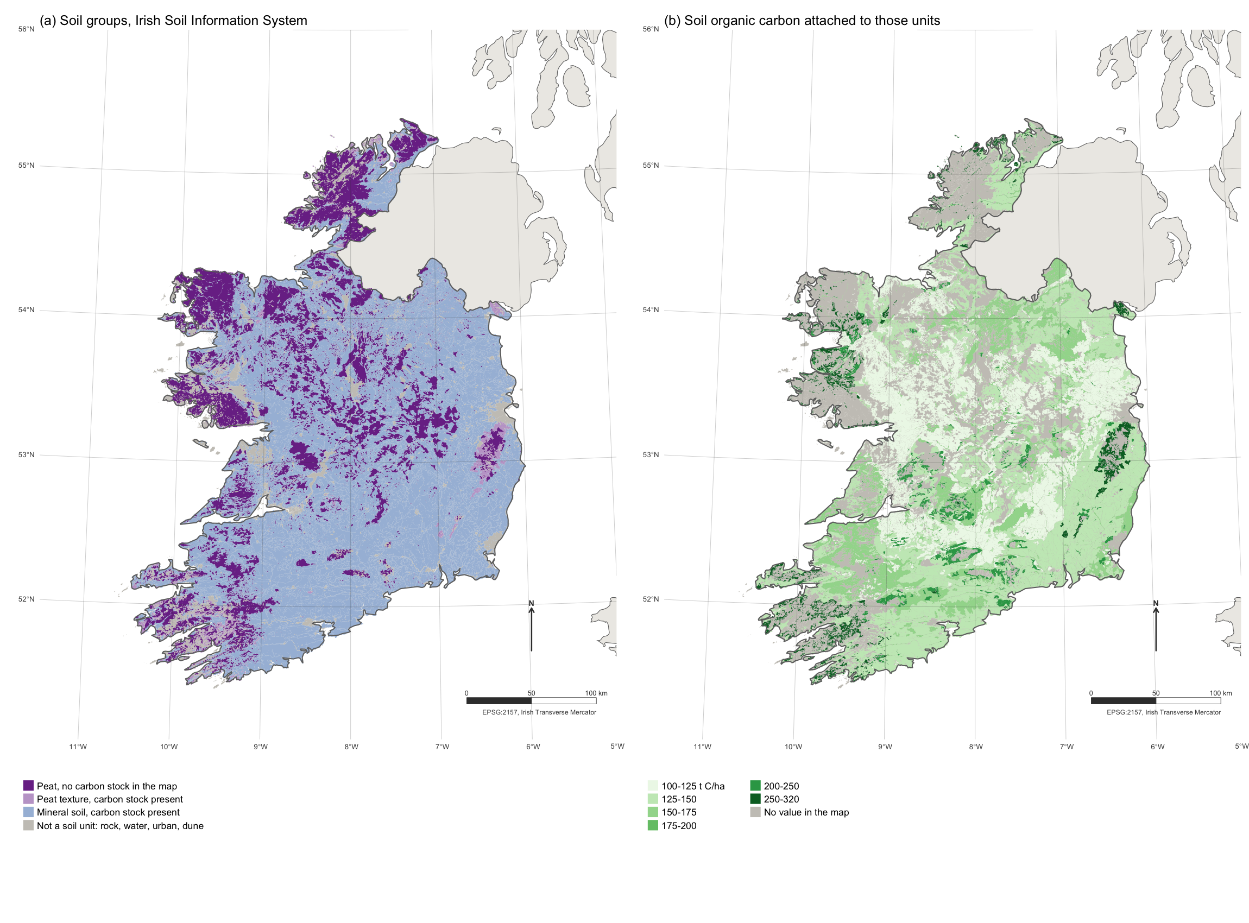
Figure S5. The Irish Soil Information System, 25,143 polygons at 1:250,000. (a) Soil groups, separating peat with no carbon stock in the map from peat that carries one, from mineral soil, from units that are not soils. (b) The soil organic carbon value attached to each unit, with the unattributed area in grey. Northern Ireland lies outside the survey and is shown unfilled. Graticule at one degree, EPSG:2157, north arrow and bar scale in the lower right.

